System Programming Assignment 3

Lexical Analysis

Assignment document

Name : GENG XU

Student ID: 12132031d

Submission contains:

This document

A lex.c source code

A compiled a.out file

A readme file for running the c code

Test sample code(input_file and input_file2)

**1.regular expression:**

1.1 KEYWORD -> var|begin|end.

1.2 COMMA -> ,

1.3 SEMICOLON -> ;

1.4 ASSIGN -> =

1.5 PERIOD -> .

1.6 PLUS -> +

1.7 MINUS -> -

1.8 MUL -> *

1.9 DIV -> /

1.10 LBRACE -> (

1.11 RBRACE -> )

1.12 NUMBER -> digit*.?digit*

1.13 ID letter(letter|digit)*

--> with letter -> A|B|C|...|Z|a|b|c|...|z

digit -> 0|1|2|...|8|9

**2.Finite Automata**

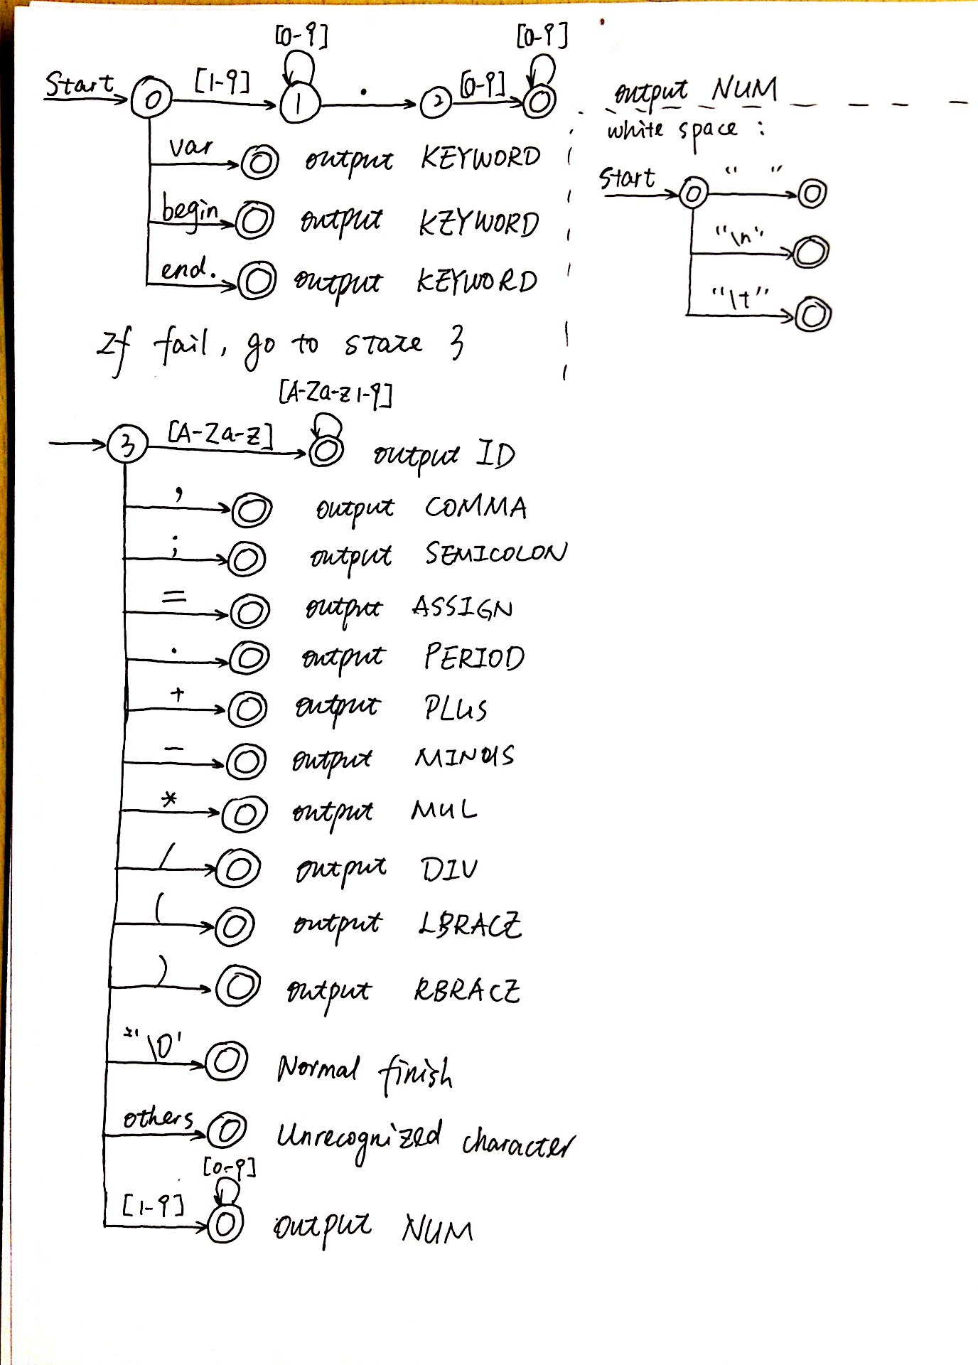

**3.program description**

**3.1 main function**

Function:

In main function, first of all, check the argument

if( argc != 2){

printf("Usage: scan input_file \n");

return -1;

}

Then ,open the file indicated by the argument

if( (fd = open(argv[1], O_RDONLY)) < 0 ){…}

finally, call the scan() function to begin lexical analysis

if (scan() > 0)

**3.2 scan() function**

Essential variables:

input_buf: pointer pointing to the string read out from the file

start_pt: pointer pointing to the start of current token

forward: pointer pointing to the current character of current token

function:

first scan the content of the target file by

rbytes = read( fd, input_buf, MAXBUFSIZE );

and append an end character to it

input_buf[rbytes-1]='\0';

then start to get tokens by get_next_token() function

while( ( ret=get_next_token() ) >= 0 ){

print_token(ret);

start_pt = start_pt + forward +1;

}

After calling get_next_token():

Normal case:

1. The return value, which is the content of the token,indicated by a tokenType enum, will be assigned to var ret.
2. Print_token() function will accept ret and print the table on the terminal
3. The start_pt will be re-located to start of next token.

Terminate case:

If the get_next_token() return -1, the lexical analysis terminate successfully.

If the get_next_token() return -2, the lexical analysis encounter undefined character

Finally, close file

close(fd);

**3.3 get_next_token() function**

Essential variables:

c: current character

forward: offset of c relative to the start of current token

current_state: state in finite automata

some basic statements:

1. Finish current token and return

// use forward to backtrack until the start of the token

for(i=0; i<=forward; i++)

token_val[i]=start_pt[i];

token_val[i]='\0'; // end current token with ‘\0’

return tokenType; // return the tokenType enum of current token

1. Deal with a looping acceptance state:

For example, to deal with numbers -> [0-9]*

if(c>47&&c<58){//is 0-9

while(1){

forward++;

c = start_pt[forward]; // go to see next character

if(!(c>47&&c<58))

break; // if not fulfill, then break the while(1) loop

}

forward--; // move backward to remove overhead

for(i=0; i<=forward; i++) // same as 1

token_val[i]=start_pt[i];

token_val[i]='\0';

return NUM;

}else{…}

function:

This function is an infinite loop to read characters in a token until the token ends

First of all, get a character to analyze

c = start_pt[forward];

Then, according to the current_state, make judgement according to the finite automata

**At state 0 (case 0):**

Firstly, need to deal with white space ‘ ’ | ’\t’ | ’\n’, accepted

if(c == ' '||c=='\t'||c=='\n'){//deal with white space

for(i=0; i<=forward; i++)

token_val[i]=start_pt[i];

token_val[i]='\0';

return delim;

}

Secondly, need to deal with NUM (actually this is only for decimal numbers), next state = 1

else if(c>48&&c<58){//is 1-9

forward++;

current_state = 1;

}

Finally, deal with KEYWORD (var|begin|end.), accepted

else{

char c_kw[5];

c_kw[0] = start_pt[forward];

c_kw[1] = start_pt[forward+1];

c_kw[2] = start_pt[forward+2];

c_kw[3] = start_pt[forward+3];

c_kw[4] = start_pt[forward+4]; //get 5 chars because the longest is “begin”

if(c_kw[0]=='v'&&c_kw[1]=='a'&&c_kw[2]=='r'){// if var

forward = 2;

}elseif(c_kw[0]=='b'&&c_kw[1]=='e'&&c_kw[2]=='g'&&c_kw[3]=='i'&&c_kw[4]=='n'){// if begin

forward = 4;

}else if(c_kw[0]=='e'&&c_kw[1]=='n'&&c_kw[2]=='d'){// if end.

forward = 2;

}else{//if fail, call fail function to go to state 3

current_state=fail(current_state);

break;

}

for(i=0; i<=forward; i++)

token_val[i]=start_pt[i];

token_val[i]='\0';

return KEYWORD;

}

**At state 1:**

If the character is a number(actually, for decimal numbers), still in state 1

if(c>47&&c<58){//is 0-9

forward++;

current_state = 1;

}

If the character is a decimal point(for decimal numbers), go to state 2

else if(c=='.'){

forward++;

current_state = 2;

}

If neither, call fail function to go to state 3

else{

current_state=fail(current_state);

}

**At state 2**

Accept state with a loop until the character is no longer a digit(0-9) (for decimal number)

if(c>47&&c<58){//is 0-9

while(1){

forward++;

c = start_pt[forward];

if(!(c>47&&c<58))

break;

}

forward--;

for(i=0; i<=forward; i++)

token_val[i]=start_pt[i];

token_val[i]='\0';

return NUM;

}

else{// if fail, go to state 3

current_state=fail(current_state);

}

**At state 3:**

If the character is one of : “,;=.+-*/()” , accept

COMMA as an example: very similar for others

case ',':

for(i=0; i<=forward; i++)

token_val[i]=start_pt[i];

token_val[i]='\0';

return COMMA;

If it is the end character ‘\0’, return -1 to indicate finish

case '\0':

return -1;

For the default of switch statement:

Firstly check for integer number

if(c>48&&c<58){//is number 1-9

while(1){// accept state with loop

forward++;

c = start_pt[forward];

if(!(c>47&&c<58))//not 0-9

break;

}

forward--;

for(i=0; i<=forward; i++)

token_val[i]=start_pt[i];

token_val[i]='\0';

return NUM;

}

Secondly, check for ID

else if((c>64&&c<91)||(c>96&&c<123)){//is letter

while(1){ //accept state with loop

forward++;

c = start_pt[forward];

if(!((c>64&&c<91)||(c>96&&c<123)||(c>47&&c<58)))//not 0-9 nor letter

break;

}

forward--;

for(i=0; i<=forward; i++)

token_val[i]=start_pt[i];

token_val[i]='\0';

return ID;

}

Finally, fail in state 3 means unrecognized characters, return -2

else{

return -2;

}

**3.4 fail()**

For finite automata, if it fails in one state, the program should know what state is the next state. In my design, fail in state 0-2 will lead the program to state 3

if( cstate < 3 )

next_state = 3;

if fail in state 3, it indicates unrecognized token, the handler is in the get_next_token() switch case 3 return -2

**3.5 print_token()**

Print the token in the terminal by accepting the TokenType enum and make judgement by switch statement

switch(token){

case NUM:

printf("NUM\t\t\t| %s\n",token_val);

break;

…

}

1. **Source code**

Attached as lex.c

1. **Input_file sample**

Attached as input_file and input_file2

Input_file is the one given with the assignment description

Input_file2 is revised a little bit by me to test IDs with mixed digits and letters.